Westman, Nick (from Linked In)

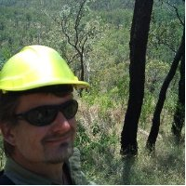

BSc Forestry ANU final year 2003.

Operations Forester, Bathurst and Harvesting Forester, Tumbarumba Forests NSW 1994 –2001. Planning Manager Walcha and Grafton Forests NSW 2001 –2011. Senior Land Assessment Officer Office of Environment & Heritage 2011 – , Grafton NSW. Responsible for mapping and field verification of old growth and rainforest on private property in NSW as per private native forestry codes of practice.

